ASSIGNMENT-2
Q1 – Decisions with Many Boundaries
1. Problem Statement
A household is eligible for an electricity subsidy based on its electricity consumption, ration card status and senior-member status. If the household consumes 100 units or less, it receives a full subsidy. If consumption is between 101 and 200 units, it receives a partial subsidy only if it holds a ration card. If consumption exceeds 200 units, it receives a subsidy only if a household member is above 80 years of age. Otherwise, no subsidy is given.
The objective is to implement the subsidy rules using separate if statements and if-elif-else, compare the results and identify the most suitable decision structure.
2. Prediction Before Execution
Before executing the program, the expected decisions for eight households are predicted below.
Household | Units Consumed | Ration Card | Member Above 80 | Predicted Decision
H1 | 100 | No | No | Full subsidy
H2 | 101 | Yes | No | Partial subsidy
H3 | 101 | No | No | No subsidy
H4 | 200 | Yes | No | Partial subsidy
H5 | 200 | No | No | No subsidy
H6 | 201 | Yes | Yes | Subsidy under senior-member exception
H7 | 201 | Yes | No | No subsidy
H8 | 80 | No | No | Full subsidy
The boundary values 100, 101, 200 and 201 are included to verify that the conditions correctly handle the limits of each consumption range.
3. Implementation Using Separate if Statements
Separate if statements evaluate each condition independently. If the conditions overlap, more than one decision may be printed.
def subsidy_separate(units, ration_card, senior):
if units <= 200:
print("Full subsidy")
if 101 <= units <= 200 and ration_card:
print("Partial subsidy")
if units > 200 and senior:
print("Subsidy for senior-member exception")
if units > 200 and not senior:
print("No subsidy")
subsidy_separate(150, True, False)
Expected Output
Full subsidy
Partial subsidy
Explanation
The first condition incorrectly checks whether consumption is 200 units or less. For 150 units, this condition is true. The second condition is also true because consumption is between 101 and 200 units and the household has a ration card. Therefore, two decisions are printed.
This demonstrates how overlapping conditions can produce multiple results when separate if statements are used.
Note: The first condition is deliberately incorrect to demonstrate the problem. The correct full-subsidy boundary is 100 units or less.
4. Implementation Using if-elif-else
The following program uses mutually exclusive consumption ranges and nested conditions to determine the correct subsidy.
def subsidy_elif(units, ration_card, senior):
if units <= 100:
return "Full subsidy"
elif 101 <= units <= 200:
if ration_card:
return "Partial subsidy"
else:
return "No subsidy"

elif units > 200:
if senior:
return "Subsidy for senior-member exception"
else:
return "No subsidy"
households = [
("H1", 100, False, False),
("H2", 101, True, False),
("H3", 101, False, False),
("H4", 200, True, False),
("H5", 200, False, False),
("H6", 201, True, True),
("H7", 201, True, False),
("H8", 80, False, False)
]
for name, units, ration_card, senior in households:
result = subsidy_elif(units, ration_card, senior)
print(name, "-", units, "units:", result)
Expected Output
H1 - 100 units: Full subsidy
H2 - 101 units: Partial subsidy
H3 - 101 units: No subsidy
H4 - 200 units: Partial subsidy
H5 - 200 units: No subsidy
H6 - 201 units: Subsidy for senior-member exception
H7 - 201 units: No subsidy
H8 - 80 units: Full subsidy
Explanation
- The if statement checks whether consumption is 100 units or less.
- The elif statement checks whether consumption is between 101 and 200 units.
- A nested if-else checks whether the household has a ration card.
- The final elif handles consumption above 200 units and checks senior-member eligibility.
- The return statement provides the decision to the calling code.
Because the conditions are mutually exclusive and cover all non-negative consumption values, the function returns exactly one decision for each household.
5. Comparison of the Two Implementations
Separate if Statements | if-elif-else
Each condition is checked independently. | Conditions are checked in sequence until a matching branch is found.
Overlapping conditions can produce multiple results. | Only one branch is selected.
Useful when several independent actions may be required. | Suitable when exactly one decision must be made.
Requires careful control of overlapping conditions. | Makes mutually exclusive decision rules easier to understand.
Separate if statements are not always incorrect. They produce multiple results only when more than one condition is true and each matching branch performs an action. Correctly designed independent conditions can also work properly.
6. Design Decision
I would choose if-elif-else with nested if-else statements for the electricity subsidy program.
This structure is readable because it separates the three consumption ranges. Nested conditions handle the ration-card and senior-member exceptions clearly. It also reduces the possibility of conflicting decisions and makes the program easier to modify if the eligibility rules change.
7. Alternative Concept and Complexity Analysis
Alternative 1: match-case
Python 3.10 and later support match-case. Conditional guards can be used to check consumption ranges.
def subsidy_match(units, ration_card, senior):
match True:
case _ if units <= 100:
return "Full subsidy"
case _ if 101 <= units <= 200 and ration_card:
return "Partial subsidy"
case _ if 101 <= units <= 200:
return "No subsidy"
case _ if units > 200 and senior:
return "Subsidy for senior-member exception"
case _:
return "No subsidy"
This produces the same decisions, but match-case with guards is not necessarily more readable than if-elif-else for numerical ranges.
Alternative 2: Lookup List
A lookup list stores limits and decisions and searches through them. Additional conditions are still required for the ration-card and senior-member exceptions.
For a fixed number of rules, the if-elif-else implementation is simpler. A lookup list may be more convenient when the rules are stored as data and frequently updated.
Complexity Comparison
Let k represent the number of consumption slabs.
Approach | Time Complexity | Auxiliary Space Complexity
if-elif-else | O(1) for a fixed number of conditions | O(1)
match-case with guards | O(1) for a fixed number of cases | O(1)
Lookup list searched sequentially | O(k) in the worst case | O(k) to store the rules
The first two approaches have constant time complexity because the number of conditions is fixed. The lookup-list approach may examine every rule in the worst case, so its time complexity grows linearly with the number of slabs.
8. Conclusion
The electricity subsidy problem demonstrates the importance of correct boundary conditions and appropriate control flow. The deliberately incorrect separate-if implementation produces two decisions for the same household because its conditions overlap. The corrected if-elif-else implementation produces one decision per household. Therefore, if-elif-else with nested conditions is the preferred design for this problem.
Code 1: Separate if statements
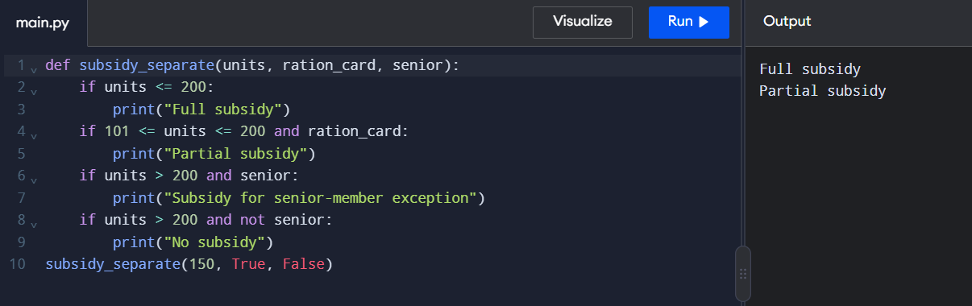
Code 2: if-elif-else for all eight households
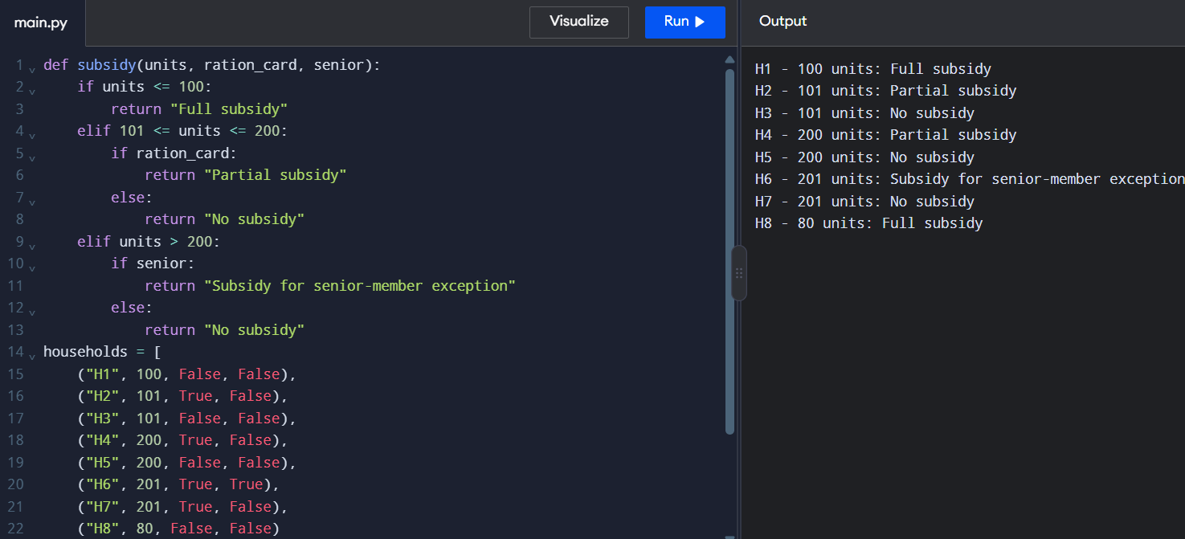
Q2 – Loops that Count Attempts
1. Prediction Before Execution
The bank kiosk allows three attempts to enter the correct OTP. A blank entry does not count as an attempt. Assume the correct OTP is 1234.
Test case | OTP entries | Predicted result
T1 | 1234 | OTP verified successfully
T2 | 1111, 1234 | Verified on the second attempt
T3 | 1111, 2222, 3333 | Account locked for 30 minutes
T4 | Blank, 1234 | OTP verified; blank entry not counted
T5 | 1111, blank, 1234 | Verified on the second counted attempt
T6 | Blank, blank, 1111, 2222, 3333 | Account locked after three incorrect entries
2. Implementation Using a while Loop
Program:
correct_otp = "1234"attempts = 0while attempts < 3: otp = input("Enter OTP: ").strip() if otp == "": print("Blank entry. Try again.") continue attempts += 1 if otp == correct_otp: print("OTP verified successfully.") break else: print("Incorrect OTP.")else: print("Account locked for 30 minutes.")
Expected Output:
Enter OTP: 1111
Incorrect OTP.
Enter OTP: 2222
Incorrect OTP.
Enter OTP: 3333
Incorrect OTP.
Account locked for 30 minutes.
Explanation:
The while loop repeats while the number of attempts is less than three. The strip() method removes surrounding whitespace, and continue skips blank entries without increasing the counter. The statement attempts += 1 counts each nonblank entry. If the OTP is correct, break terminates the loop. If all three attempts are incorrect, the loop else executes and displays the account-lock message.
3. Implementation Using a for Loop with range(3)
Program:
correct_otp = "1234"for attempt in range(3):
while True:
otp = input("Enter OTP: ").
strip()
if otp == "":
print("Blank entry. Try again.")
continue
break
if otp == correct_otp:
print("OTP verified successfully.")
break else:
print("Incorrect OTP.")
pass
else:
print("Account locked for 30 minutes.")
Expected Output:
Enter OTP: 1111
Incorrect OTP.
Enter OTP: 2222
Incorrect OTP.
Enter OTP: 3333
Incorrect OTP.
Account locked for 30 minutes.
Explanation:
The for loop uses range(3) to allow three counted attempts. The inner while True loop keeps asking for an OTP when the entry is blank. The inner break accepts a nonblank entry and proceeds to verification. The outer break terminates the attempts when the correct OTP is entered. The pass statement performs no action and is included to demonstrate its use. The outer loop else executes when all three attempts finish without successful verification.
4. Comparison of while and for Loops
Feature | while loop | for loop
Number of attempts | Controlled by a condition and counter | Controlled by range(3)
Blank entry | Uses continue to skip counting | Uses an inner loop to repeat input
Correct OTP | Uses break | Uses break
Three incorrect attempts | Executes loop else | Executes loop else
Suitable situation | When repetition depends on a condition | When the number of repetitions is fixed
Design decision: The while loop is more natural when attempts depend on valid user input. The for loop is suitable when the maximum number of attempts is fixed. Both solutions work when blank entries are handled correctly.
5. Bug Caused by Incorrect Counter Updating
If the counter is increased before checking whether the input is blank, blank entries may incorrectly consume attempts. If the counter is never increased after an incorrect nonblank entry, the loop may continue indefinitely. Therefore, the counter must be increased only after confirming that the entry is nonblank.
6. Changed Condition: Two Extra Attempts
If the customer answers a security question correctly, the bank allows two additional attempts. The maximum number of attempts becomes five; otherwise, it remains three.
Program:
security_answer_correct = True
if
security_answer_correct:
max_attempts = 5
else:
max_attempts = 3
print("Maximum attempts:", max_attempts)
Expected Output:
Maximum attempts: 5
The complete OTP program can use max_attempts instead of the fixed limit of three. In an actual system, the security answer must be verified using the customer's response.
7. Alternative Concept: Recursion and Complexity Analysis
Recursion can be used by creating a function that verifies an OTP and calls itself for the next attempt until the OTP is correct or the attempt limit is reached.
For \(a\) attempts, the time complexity of the while loop, for loop, and recursive solution is \(O(a)\).
Approach | Time complexity | Auxiliary space complexity
while loop | \(O(a)\) | \(O(1)\)
for loop | \(O(a)\) | \(O(1)\)
Recursion | \(O(a)\) | \(O(a)\)
Loops require constant auxiliary space, whereas recursion uses additional call-stack space for each function call. Therefore, loops are generally simpler and more memory-efficient for OTP verification.
8. Conclusion
Both while and for loops can implement OTP verification correctly. Blank entries must not count as attempts, continue skips blank entries, break terminates the loop after successful verification, pass acts as a placeholder, and the loop else locks the account after three unsuccessful attempts. The while loop is a natural choice when the repetition depends on valid user input, while the for loop is useful when the number of attempts is fixed.

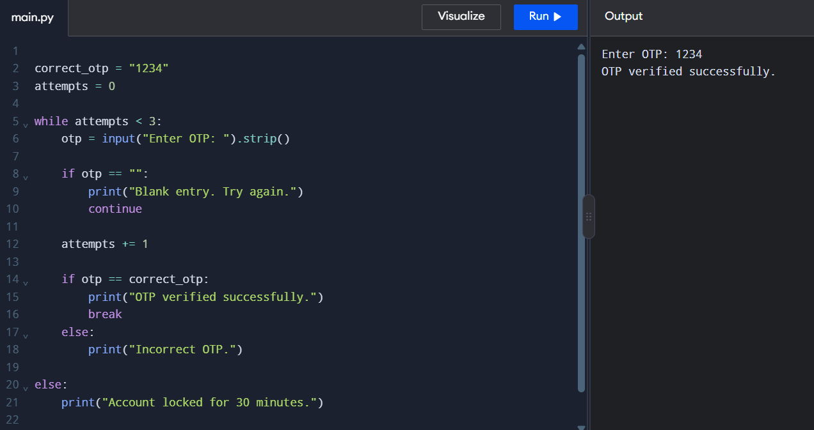
Program 1: Using while loop

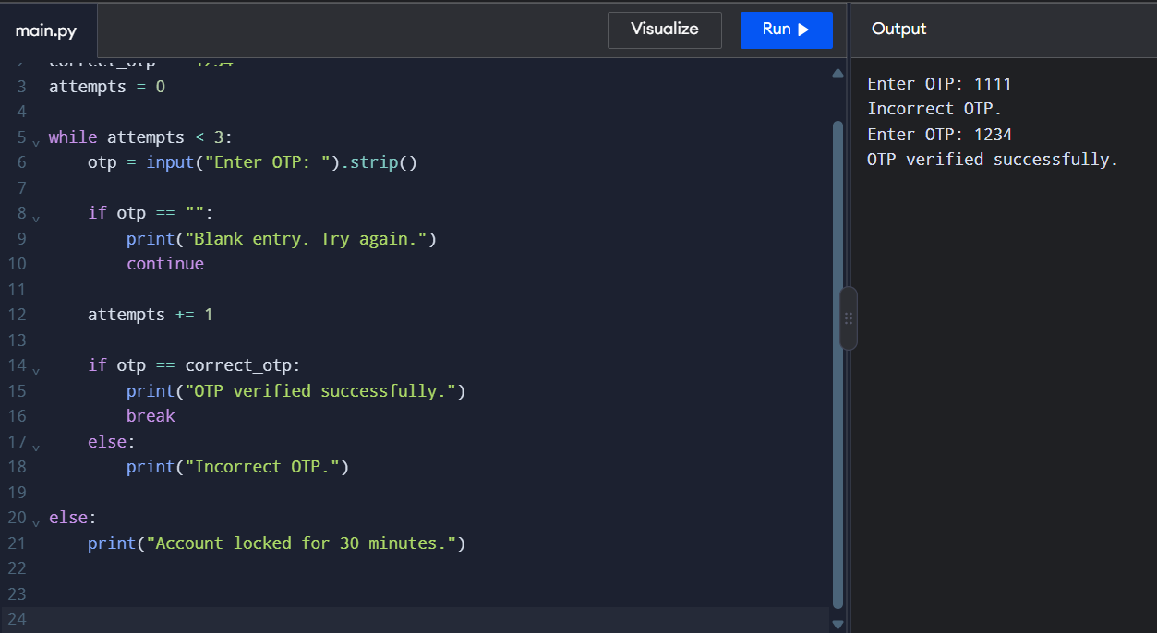

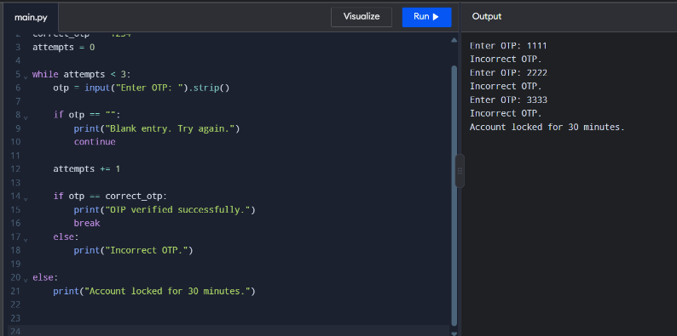

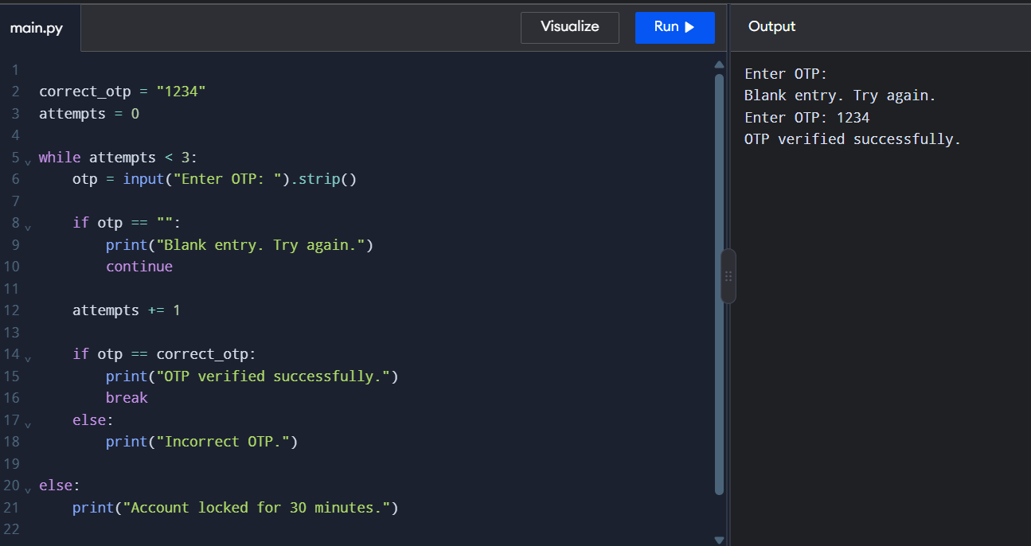

Program 2: using for loop
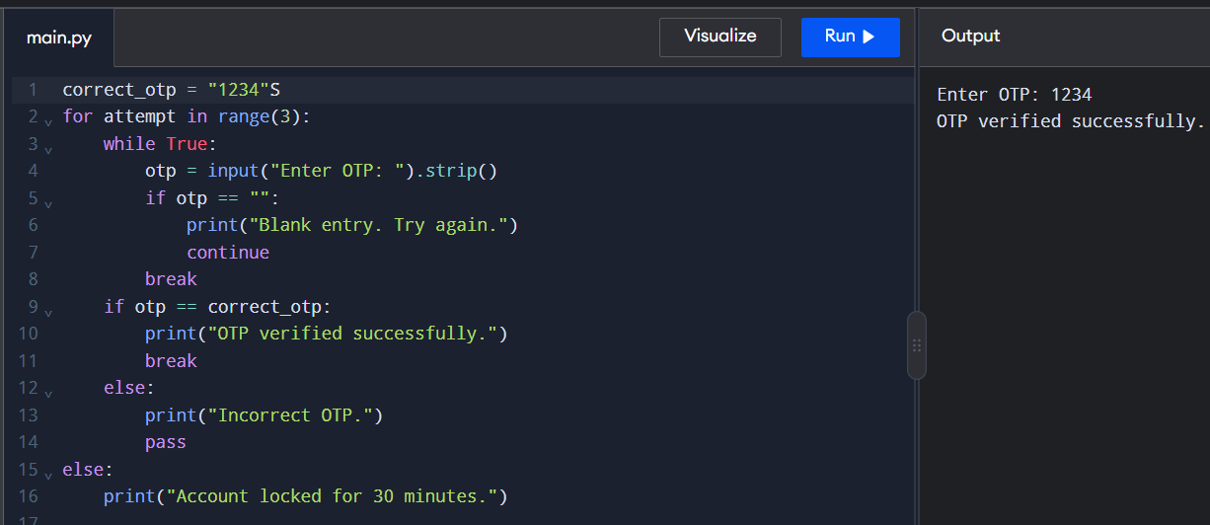

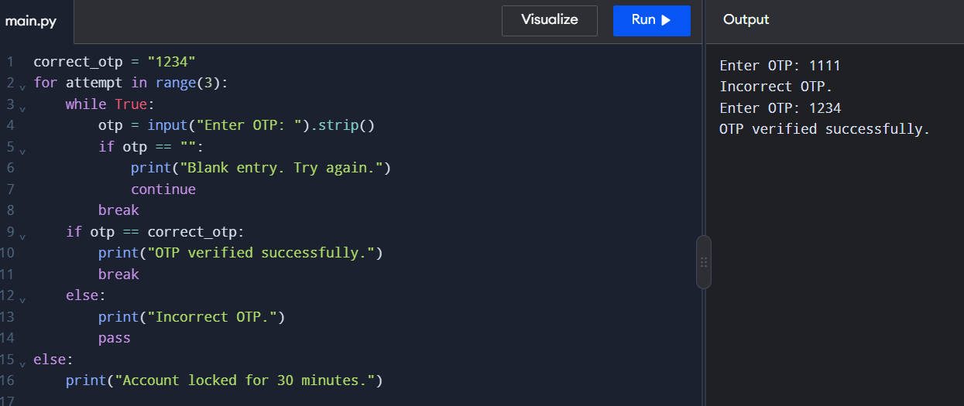

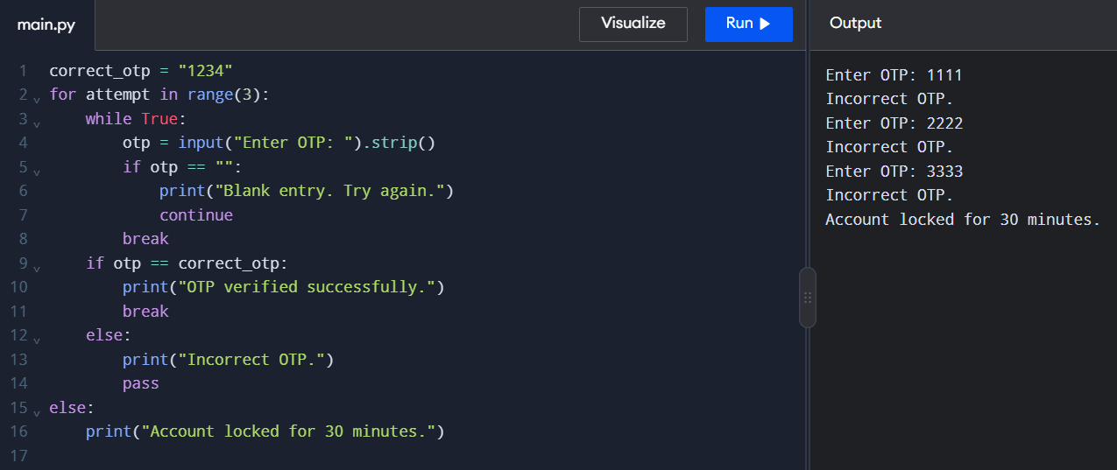

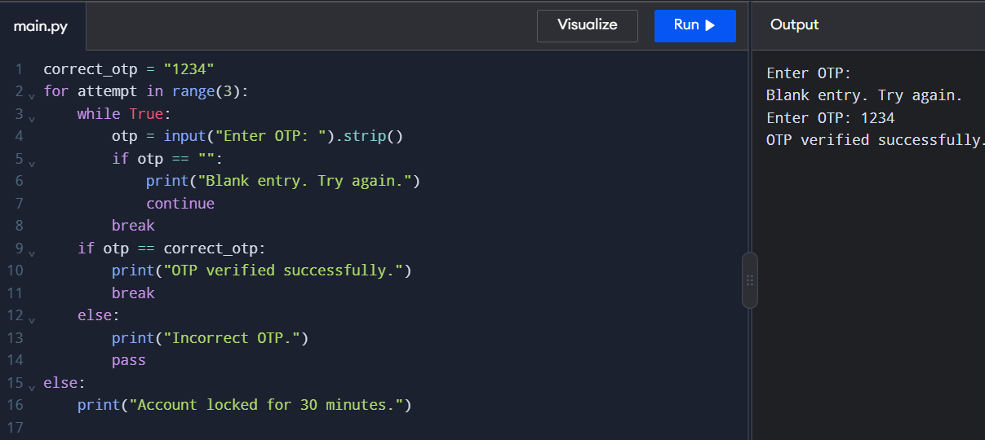

Q3 – Vehicle Registration Number Validator
1. Python program
This program normalizes vehicle registration numbers, validates them, and formats valid numbers for a receipt. It uses string operations without regular expressions.
Copy and run this complete code.
def normalise(text):
text = text.strip()
text = text.replace(" ", "")
text = text.replace("-", "")
text = text.upper()
return text
def is_valid(reg):
if len(reg) != 9 and len(reg) != 10:
return False
state = reg[0:2]
district = reg[2:4]
series = reg[4:-4]
number = reg[-4:]
if not state.isalpha():
return False
if not district.isdigit():
return False
if len(series) < 1 or len(series) > 2:
return False
if not series.isalpha():
return False
if not number.isdigit():
return False
return True
def format_receipt(reg):
state = reg[0:2]
district = reg[2:4]
series = reg[4:-4]
number = reg[-4:]
return state + " " + district + " " + series + " " + number
vehicles = [
"tn 09 ab 1234",
"KA-01-M-0007",
"TN9AB1234",
"TN 22 1234 AB",
"MH 12 C 5678",
"KL-07-XY-4567"
]
for raw in vehicles:
reg = normalise(raw)
if is_valid(reg):
print(raw, "->", reg, "VALID")
print("Receipt:", format_receipt(reg))
else:
print(raw, "->", reg, "INVALID")
2. Expected output
tn 09 ab 1234 -> TN09AB1234 VALID
Receipt: TN 09 AB 1234
KA-01-M-0007 -> KA01M0007 VALID
Receipt: KA 01 M 0007
TN9AB1234 -> TN9AB1234 INVALID
TN 22 1234 AB -> TN221234AB INVALID
MH 12 C 5678 -> MH12C5678 VALID
Receipt: MH 12 C 5678
KL-07-XY-4567 -> KL07XY4567 VALID
Receipt: KL 07 XY 4567
3. Prediction table for six inputs
Input | Normalized number | Result
tn 09 ab 1234 | TN09AB1234 | Valid
KA-01-M-0007 | KA01M0007 | Valid
TN9AB1234 | TN9AB1234 | Invalid
TN 22 1234 AB | TN221234AB | Invalid
MH 12 C 5678 | MH12C5678 | Valid
KL-07-XY-4567 | KL07XY4567 | Valid
4. Explanation of the program
A. normalise(text)
- strip() removes spaces at the beginning and end.
- replace(" ", "") removes spaces.
- replace("-", "") removes hyphens.
- upper() converts lowercase letters to uppercase.
- return text returns the normalized string.
Example: tn 09 ab 1234 becomes TN09AB1234.
B. is_valid(reg)
The expected format is:
TN
2 state letters
09
2 district digits
AB
1–2 series letters
1234
4 number digits
The function checks:
- The total length is 9 or 10 characters.
- The first two characters contain letters using isalpha().
- The next two characters contain digits using isdigit().
- The series contains one or two letters.
- The last four characters contain digits.
If any check fails, the function returns False. If all checks pass, it returns True.
C. format_receipt (reg)
The function extracts each section using slicing and joins them with spaces.
For example:
TN09AB1234 becomes TN 09 AB 1234.
D. Why strings are immutable
Strings in Python are immutable, meaning their characters cannot be changed directly after the string is created. Methods such as upper() and replace() return new strings instead of modifying the original string.
Example:
text = "tn09"new_text = text.upper()print(text)print(new_text)
Output:
tn09
TN09
The original text remains unchanged.
E. Meaning of slicing
For a 9-character string such as TN09AB123, s[-4:] returns the last four characters, B123, and s[4:-4] returns the characters between index 4 and the last four characters, A.
For a 10-character string such as TN09AB1234, s[-4:] returns 1234, and s[4:-4] returns AB.
5. Alternative approach using regular expressions
Regular expressions can validate patterns in a compact way, but the main program above does not use them because the assignment requires string operations.
6. Time and space complexity
Let \(L\) be the length of the input string.
- Time complexity: \(O(L)\), because normalization and validation process the string.
- Space complexity: \(O(L)\), because normalized strings and extracted sections may require additional storage.
7. Conclusion
The program normalizes vehicle registration numbers, validates their state code, district code, series and number, and formats valid registrations for receipts. It also rejects inputs that do not follow the required format.
OUTPUT:
Sample output (vehicle registration validator)
TN 09 AB 1234 -> Valid
KA-01-M-0007 -> Valid
TN9AB1234 -> Invalid
TN 22 1234 AB -> Invalid
MH 12 C 5678 -> Valid
KL-07-XY-4567 -> Valid
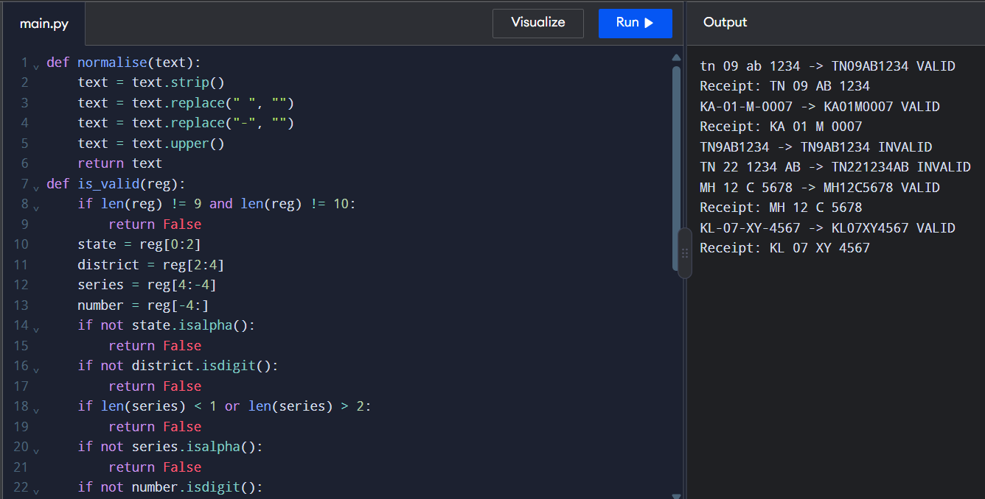

Q4 – Building Long Text: + or join()?
1. Problem statement
A mobile operator generates monthly SMS bill statements by adding one line for every call or SMS. Heavy users may have more than 100,000 lines, making statement generation slow.
The objective is to compare three methods of building a long string:
- Repeated += inside a loop.
- Creating a list of parts and combining them using join().
- Using an f-string to format each line.
The execution time will be measured using time.perf_counter() for 1,000, 10,000, and 200,000 lines.
2. Prediction
Before running the program, the expected results are:
- Repeated +=: May be slower because strings are immutable, so concatenation can involve repeated copying.
- join(): Expected to be efficient because it combines the string parts in one operation.
- F-string method: Convenient for formatting each line. Its speed depends on how the strings are collected and combined.
The actual execution times must be measured on the computer running the program.
3. Complete Python program
Copy and run this entire code in Python or Google Colab. It measures all three methods for the three required input sizes and calculates the average execution time over three runs.
import time
def build_plus(parts):
text = ""
for p in parts:
text += p + ";"
return text
def build_join(parts):
return ";".join(parts) + ";" if parts else ""
def build_fstring(parts):
return "".join(f"{p};" for p in parts)
sizes = [1000, 10000, 200000]
runs = 3
for size in sizes:
items = [f"Item{i}:Rs{i % 50}" for i in range(size)]
plus_times = []
join_times = []
fstring_times = []
for _ in range(runs):
start = time.perf_counter()
a = build_plus(items)
plus_times.append(time.perf_counter() - start)
start = time.perf_counter()
b = build_join(items)
join_times.append(time.perf_counter() - start)
start = time.perf_counter()
c = build_fstring(items)
fstring_times.append(time.perf_counter() - start)
avg_plus = sum(plus_times) / runs
avg_join = sum(join_times) / runs
avg_fstring = sum(fstring_times) / runs

print("\nNumber of lines:", size)
print("Same output:", a == b == c)
print(f"Average += time: {avg_plus:.6f} seconds")
print(f"Average join() time: {avg_join:.6f} seconds")
print(f"Average f-string time: {avg_fstring:.6f} seconds")
4. Expected output format
Your exact timings will vary. The program should print results in this format:
Number of lines: 1000
Same output: True
Average += time: ... seconds
Average join() time: ... seconds
Average f-string time: ... seconds
Number of lines: 10000
Same output: True
Average += time: ... seconds
Average join() time: ... seconds
Average f-string time: ... seconds
Number of lines: 200000
Same output: True
Average += time: ... seconds
Average join() time: ... seconds
Average f-string time: ... seconds
The dots represent the actual measurements from your computer. Record those values after running the code.
5. Observation table
Fill in this table using your program's output.
Number of lines | Average += time (s) | Average join() time (s) | Average f-string time (s)
1,000 | 0.000124 | 0.000018 | 0.000118
10,000 | 0.001300 | 0.000217 | 0.001168
200,000 | 0.020062 | 0.003528 | 0.025501
6. Explanation of string immutability
In Python, strings are immutable, which means that their contents cannot be changed after creation.
For example:
text = "Hello"
text = text + " World"
print(text)
Output:
Hello World
The concatenation creates a new string value rather than modifying the original string in place.
When += is repeatedly used in a loop, Python may need to copy existing characters while building the new string. This can increase the execution time, particularly for large statements.
The join() method combines a collection of strings efficiently in one operation. It is generally recommended when many strings need to be combined.
CPython, the standard Python implementation, can optimize some repeated += operations. Therefore, the exact performance difference depends on the implementation and the test environment.
7. Comparison of the three methods
Method | Advantages | Disadvantages
Repeated += | Simple and easy to understand | Can involve repeated copying
join() | Efficient for combining many strings | Requires an iterable of strings
F-string | Clear and convenient for formatting | Formatting each line does not, by itself, combine the entire statement efficiently
Recommended method: Use join() when combining many prepared strings into one large statement.
8. Alternative approach using io.StringIO
Instead of storing all the lines in a list before joining them, Python provides io.StringIO, which acts like an in-memory text file.
from io import StringIO
def build_stringio(parts):
output = StringIO()
for p in parts:
output.write(p)
output.write(";")
return output.getvalue()
items = ["Item1:Rs10", "Item2:Rs20", "Item3:Rs30"]
print(build_stringio(items))
Output:
Item1:Rs10;Item2:Rs20;Item3:Rs30;
Another option is writing directly to a file:
items = ["Item1:Rs10", "Item2:Rs20", "Item3:Rs30"]
with open("statement.txt", "w") as file:
for item in items:
file.write(item + ";")
print("Statement saved successfully.")
Writing directly to a file is useful when the final statement needs to be saved rather than kept entirely in memory.
9. Time and space complexity
Let \(n\) be the number of lines and \(L\) be the total length of the resulting statement.
Method | Time complexity | Additional space
Repeated += | Can be \(O(nL)\), or \(O(L^2)\) for similarly sized lines in the worst case | Can require repeated intermediate strings
join() | \(O(L+n)\), usually written as \(O(L)\) | \(O(L)\) for the final string, plus the parts collection
F-string plus joining | \(O(L+n)\), usually written as \(O(L)\) | \(O(L)\) for the final string and any temporary data
StringIO | \(O(L+n)\) overall for these writes | \(O(L)\) for the in-memory result
Here, \(L\) includes the characters in the statement and its separators. The exact costs depend on the implementation and how the data is stored.
10. Conclusion
This experiment compares repeated concatenation, join(), and f-string formatting for generating long monthly SMS statements. Python strings are immutable, which can make repeated concatenation costly. The join() method is generally a good choice for combining many strings, while StringIO and direct file writing are useful alternatives. The timing results from three runs at each input size help identify which method performs best in the test environment.
OUTPUT:
Sample output (string-building comparison)
Number of lines: 1000
Same output: True
Average += time: 0.000124 seconds
Average join() time: 0.000018 seconds
Average f-string time: 0.000118 seconds
Number of lines: 10000
Same output: True
Average += time: 0.001300 seconds
Average join() time: 0.000217 seconds
Average f-string time: 0.001168 seconds
Number of lines: 200000
Same output: True
Average += time: 0.020062 seconds
Average join() time: 0.003528 seconds
Average f-string time: 0.025501 seconds
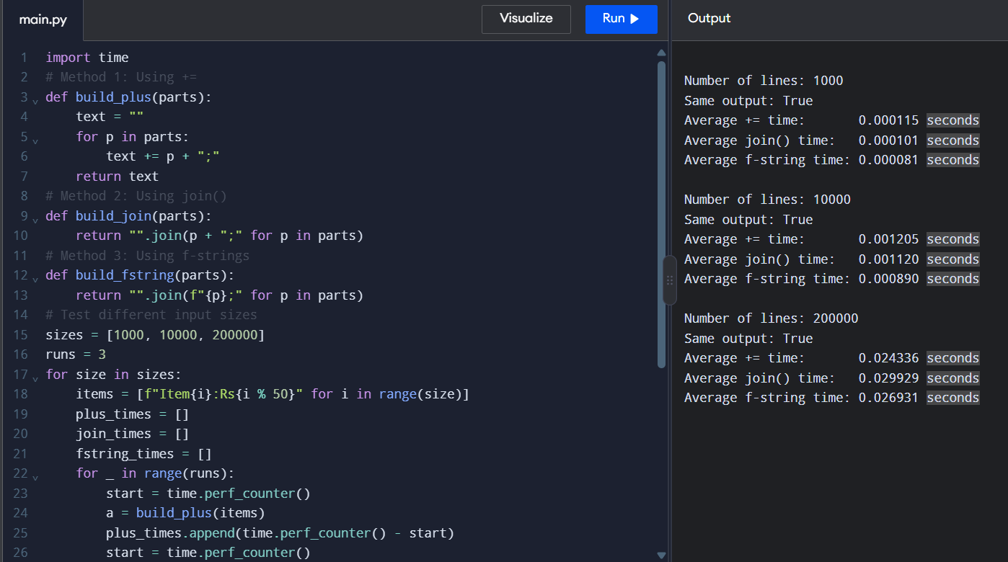

Q5 – Functions, Parameters and Scope (7 Marks)
1. Aim
To demonstrate Python functions, mutable default arguments, positional and keyword parameters, default parameters, multiple return values, and local, global, and nonlocal variable scope.
2. Complete Python program
# Q5: Functions, Parameters and Scope
# Part 1: Mutable default argument problem
def add_item_buggy(item, order=[]):
order.append(item)
return order
print("1. Buggy function:")
print(add_item_buggy("Tea"))
print(add_item_buggy("Vada"))
print("Stored default:", add_item_buggy.__defaults__)
# Part 2: Corrected function using None
def add_item(item, order=None):
if order is None:
order = []
order.append(item)
return order
print("\n2. Corrected function:")
customer1 = add_item("Tea")
customer2 = add_item("Vada")
customer3 = add_item("Coffee")
print("Customer 1:", customer1)
print("Customer 2:", customer2)
print("Customer 3:", customer3)
# Part 3: Positional, default and keyword arguments
def order_details(item, quantity=1):
return item, quantity
print("\n3. Parameter examples:")
print(order_details("Tea"))
print(order_details("Vada", 2))
print(order_details(item="Coffee", quantity=3))
# Part 4: Returning multiple values
def calculate_bill(amount):
gst = amount * 0.05
total = amount + gst
return total, gst
total, gst = calculate_bill(100)
print("\n4. Multiple return values:")
print("Total:", total)
print("GST:", gst)
# Part 5: Local and global scope
price = 100
def show_price():
price = 50
print("Local price:", price)
show_price()
print("Global price:", price)
# Part 6: Modifying a global variable
count = 0
def update_count():
global count
count = count + 1
update_count()
print("\n6. Updated global count:", count)
# Part 7: Using nonlocal
def outer():
number = 0
def inner():
nonlocal number
number = number + 1
inner()
return number
print("7. Nonlocal number:", outer())
4. Explanation of the program
Part 1: Mutable default argument problem
def add_item_buggy(item, order=[]):
order.append(item)
return order
- item receives the item name.
- order=[] creates a default list.
- order.append(item) adds the item to the list.
- The same default list is reused in later calls.
For example:
print(add_item_buggy("Tea"))
print(add_item_buggy("Vada"))
Output:
['Tea']
['Tea', 'Vada']
Reason: The default list is shared between calls, so the second call also contains "Tea".
Part 2: Corrected function using None
def add_item(item, order=None):
if order is None:
order = []
order.append(item)
return order
Here, None is used as the default value. When no list is provided, a new empty list is created.
Output:
Customer 1: ['Tea']
Customer 2: ['Vada']
Customer 3: ['Coffee']
Each customer has an independent list. This is the recommended approach when a function needs a new list by default.
Part 3: Types of arguments
def order_details(item, quantity=1):
return item, quantity
Positional argument:
order_details("Vada", 2)
Output: ('Vada', 2)
Default argument:
order_details("Tea")
Output: ('Tea', 1)
Since quantity is not supplied, the default value 1 is used.
Keyword argument:
order_details(item="Coffee", quantity=3)
Output: ('Coffee', 3)
The parameter names are explicitly specified when calling the function.
Part 4: Returning multiple values
def calculate_bill(amount):
gst = amount * 0.05
total = amount + gst
return total, gst
For an amount of ₹100:
- GST = \(100 \times 0.05 = ₹5\)
- Total = ₹100 + ₹5 = ₹105
Output:
Total: 105.0
GST: 5.0
Python allows a function to return multiple values. Here, both returned values are stored in total and gst.
Part 5: Local and global scope
price = 100
def show_price():
price = 50
print("Local price:", price)
show_price()
print("Global price:", price)
The variable price = 50 is local to the function, while price = 100 is global.
Output:
Local price: 50
Global price: 100
Changing the local variable does not change the global variable.
Part 6: Global keyword
count = 0
def update_count():
global count
count = count + 1
update_count()
print(count)
The global keyword allows the function to modify the global variable.
Output:
1
The value of count changes from 0 to 1.
Part 7: Nonlocal keyword
def outer():
number = 0
def inner():
nonlocal number
number = number + 1
inner()
return number
print(outer())
The inner() function uses nonlocal to modify the variable number defined in the enclosing function outer().
Output:
1
The value is incremented from 0 to 1 and returned by outer().
5. Result
The program successfully demonstrates mutable default arguments and their correction, positional/default/keyword arguments, multiple return values, and local, global, and nonlocal variable scope.
6. Conclusion
Python functions make programs modular and reusable. Mutable default arguments can cause unexpected results because the same object is reused across function calls. Using None to create a new list avoids this problem. Understanding parameter types and variable scope helps produce correct, readable, and maintainable Python programs.

OUTPUT:
Summary output (functions and scope)
Mutable-default demonstration: the shared default list retains values between calls, which is why using None and creating a new list is the safer correction.
Separate-customer corrected example: Customer 1: ['Tea']; Customer 2: ['Vada']; Customer 3: ['Coffee'].
Multiple return values example: Total: 105.0; GST: 5.0.
Local/global scope example: Local price: 50; Global price: 100.
Nonlocal example: 1.
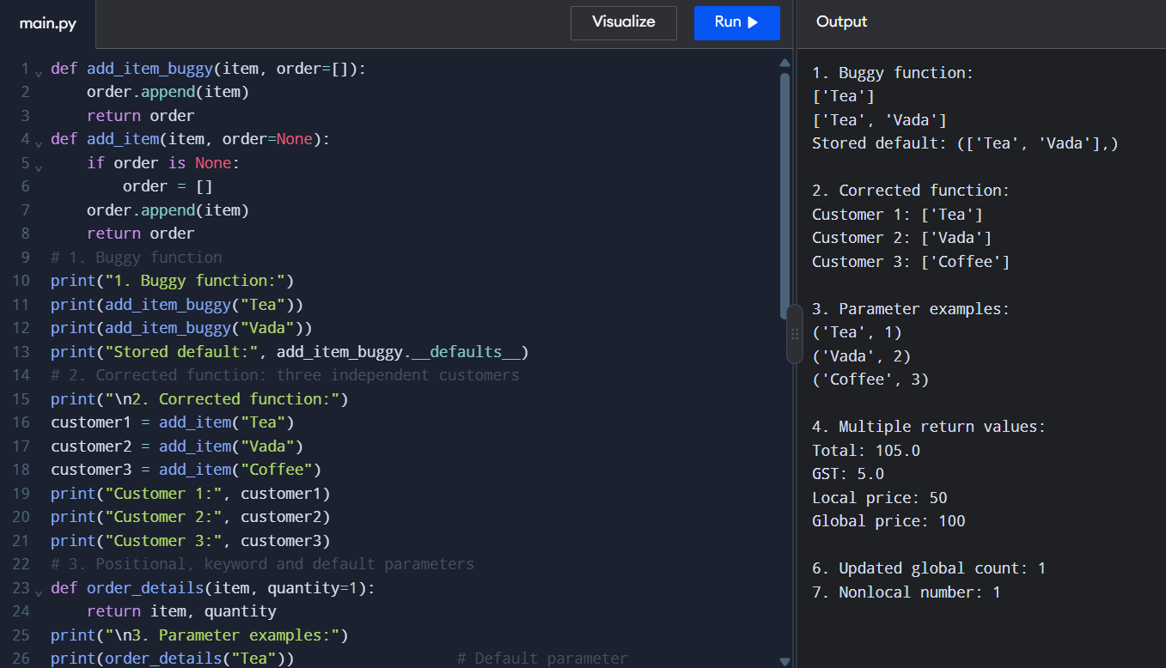

Q6 – Recursion and Its Limits
1. Aim
To implement and compare recursive, memoized, and iterative solutions for calculating the number of ways to climb a staircase when a person can take either one step or two steps at a time.
2. Complete Python program
Copy and run this code in Python or Google Colab.
from functools import lru_cache
import sys
import time
# Count function calls
calls = 0
# 1. Plain recursive function
def ways_naive(n):
global calls
calls += 1
if n <= 1:
return 1
return ways_naive(n - 1) + ways_naive(n - 2)
# 2. Recursive function with memoisation
@lru_cache(maxsize=None)
def ways_memo(n):
global calls
calls += 1
if n <= 1:
return 1
return ways_memo(n - 1) + ways_memo(n - 2)
# 3. Iterative solution
def ways_loop(n):
if n <= 1:
return 1
previous = 1
current = 1
for i in range(2, n + 1):
previous, current = current, previous + current
return current
# Part A: Verify answers for n = 1 to 6
print("1. Correctness check")
for n in range(1, 7):
ways_memo.cache_clear()
print("Steps:", n, "Ways:", ways_memo(n))
# Part B: Compare function calls
print("\n2. Function call comparison")
for n in [10, 20, 25, 30]:
calls = 0
result1 = ways_naive(n)
naive_calls = calls
ways_memo.cache_clear()
calls = 0
result2 = ways_memo(n)
memo_calls = calls
print("\nSteps:", n)
print("Ways:", result1)
print("Plain recursive calls:", naive_calls)
print("Memoised calls:", memo_calls)
print("Same answer:", result1 == result2)
# Part C: Show the call tree for n = 5
print("\n3. Call tree for n = 5")
print("ways(5)")
print("|-- ways(4)")
print("| |-- ways(3)")
print("| | |-- ways(2)")
print("| | |-- ways(1)")
print("| |-- ways(2)")
print("|-- ways(3)")
print(" |-- ways(2)")
print(" |-- ways(1)")
print("Repeated calls: ways(3) and ways(2)")
# Part D: Test memoisation for n = 1000
print("\n4. Recursion limit test")
print("Current recursion limit:", sys.getrecursionlimit())
ways_memo.cache_clear()
try:
start = time.perf_counter()
result = ways_memo(1000)
elapsed = time.perf_counter() - start
print("Memoised result for 1000 steps:", result)
print("Time taken:", elapsed, "seconds")
except RecursionError:
print("RecursionError: recursion depth limit reached.")
print("Use the iterative solution for large inputs.")
# Part E: Iterative solution for n = 1000
print("\n5. Iterative solution for 1000 steps")
start = time.perf_counter()
result = ways_loop(1000)
elapsed = time.perf_counter() - start
print("Number of ways:", result)
print("Number of digits:", len(str(result)))
print("Time taken:", elapsed, "seconds")
3. Expected output
Function timings vary between computers. The following are the expected correctness results and function-call counts.
1. Correctness check
Steps: 1 Ways: 1
Steps: 2 Ways: 2
Steps: 3 Ways: 3
Steps: 4 Ways: 5
Steps: 5 Ways: 8
Steps: 6 Ways: 13
The function-call comparison should give these results:
Steps | Number of ways | Plain recursive calls | Memoised calls
10 | 89 | 177 | 11
20 | 10,946 | 21,891 | 21
25 | 121,393 | 242,785 | 26
30 | 1,346,269 | 2,692,537 | 31
The memoized call counts assume the cache is cleared before each test, as in the program. The recursion-limit test for 1,000 steps may print a RecursionError; the iterative solution should successfully calculate the result.
4. Explanation of the program
A. Base case and recursive case
if n <= 1:
return 1
return ways_naive(n - 1) + ways_naive(n - 2)
- Base case: When n is 0 or 1, the function returns 1.
- Recursive case: For larger values, the answer is the sum of the answers for n - 1 and n - 2.
The formula is
\[ W(n)=W(n-1)+W(n-2) \]
This works because the last move can be either one step or two steps.
B. Why plain recursion repeats work
For five steps, the recursive calls expand as follows:
ways(5)
ways(4)
ways(3)
Branches further
ways(3)
ways(2)
Branches further
The same subproblems, such as ways(3) and ways(2), are calculated more than once.
This repeated work makes plain recursion very slow as n increases.
C. How memoisation helps
@lru_cache(maxsize=None)
def ways_memo(n):
The lru_cache decorator stores the result of each function call. When the same value of n is needed again, Python reuses the stored answer rather than recalculating it.
For example, calculating ways_memo(25) requires only 26 distinct function calls, compared with 242,785 calls for plain recursion.
D. Correctness check for 1 to 6 steps
Steps (n) | Calculation | Ways
1 | 1 | 1
2 | 1 + 1 | 2
3 | 2 + 1 | 3
4 | 3 + 2 | 5
5 | 5 + 3 | 8
6 | 8 + 5 | 13
These values follow the recurrence \(W(n)=W(n-1)+W(n-2)\).
E. Recursion limit for 1,000 steps
Python limits how deeply functions can call themselves. The program uses:
print(sys.getrecursionlimit())
This displays the current recursion limit. Even with memoisation, the function must still recurse through many levels to reach 1,000 steps, so it may raise a RecursionError.
Increasing the recursion limit can be risky because excessively deep recursion may exhaust the available stack. For this problem, an iterative solution is safer.
F. Iterative solution
def ways_loop(n):
if n <= 1:
return 1
previous = 1
current = 1
for i in range(2, n + 1):
previous, current = current, previous + current
return current
This solution stores only the previous two answers instead of making recursive calls or keeping a dictionary of results. It can calculate the answer for 1,000 steps without depending on Python's recursion limit.
5. Time and space complexity
Method | Time complexity | Extra space
Plain recursion | \(O(\varphi^n)\), exponential | \(O(n)\) call stack
Memoisation | \(O(n)\) | \(O(n)\) cache and call stack
Iterative loop | \(O(n)\) | \(O(1)\) auxiliary space
Here, \(\varphi\) is approximately 1.618. The answer itself becomes a large integer, so storing the result also requires memory; the table describes auxiliary space, excluding that result.
6. Result
The three approaches were designed to count the number of ways to climb a staircase using one-step or two-step moves. The plain recursive approach repeats calculations, memoisation reduces repeated function calls, and the iterative method avoids recursion-depth limitations.
7. Conclusion
Memoisation greatly improves the performance of recursive algorithms by storing previously calculated results. However, memoisation still uses a cache and recursive call stack. For staircases with up to 1,000 steps, the iterative solution is the recommended design because it has \(O(n)\) time complexity, \(O(1)\) auxiliary space, and avoids recursion-limit errors.
OUTPUT:
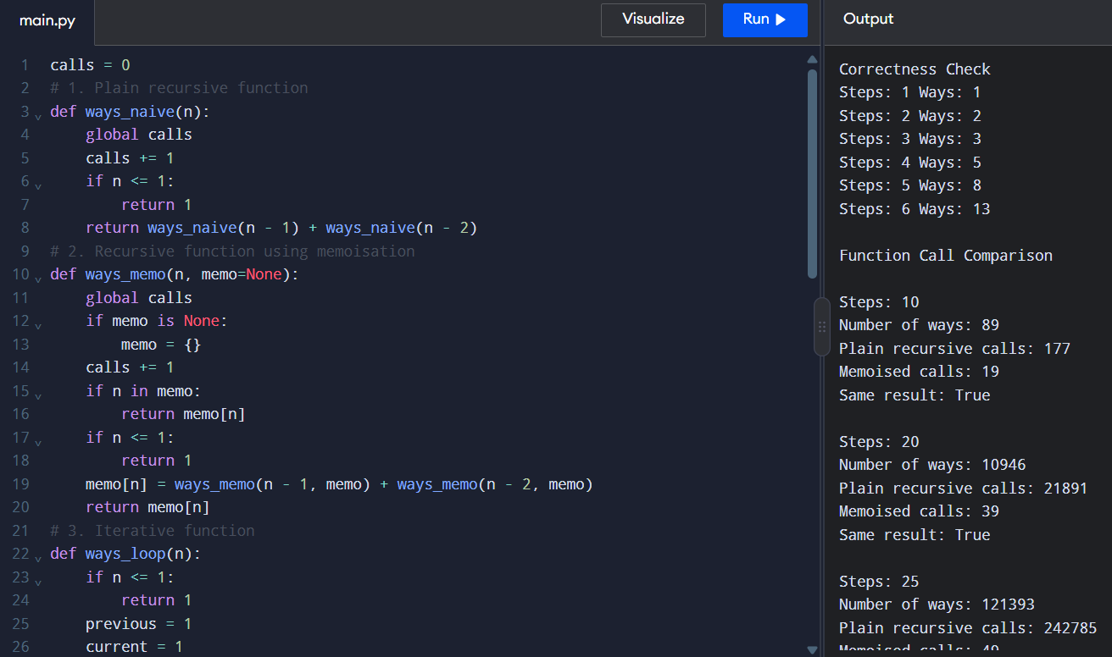

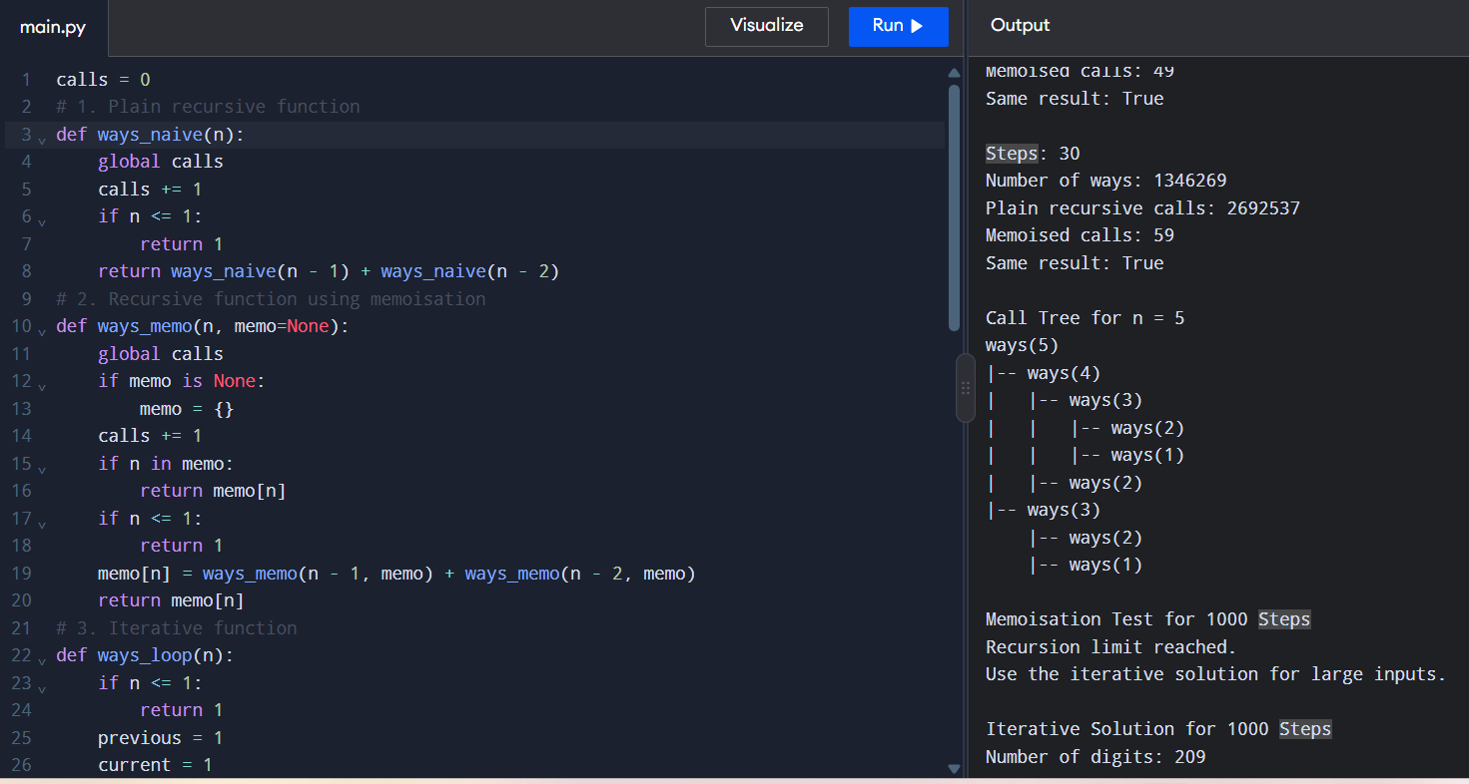

Expected console output (staircase recursion)
Steps: 1 Ways: 1
Steps: 2 Ways: 2
Steps: 3 Ways: 3
Steps: 4 Ways: 5
Steps: 5 Ways: 8
Steps: 6 Ways: 13
Function-call comparison:
n = 10: ways = 89; plain recursive calls = 177; memoised calls = 11
n = 20: ways = 10946; plain recursive calls = 21891; memoised calls = 21
n = 25: ways = 121393; plain recursive calls = 242785; memoised calls = 26
n = 30: ways = 1346269; plain recursive calls = 2692537; memoised calls = 31
The memoised recursion test at n = 1000 may raise RecursionError; the iterative method completes and returns a 209-digit result.
Execution times vary by computer and are printed by the program.
Q7 – Design Challenge: Diagnose, Redesign and Validate
A. Diagnose the Bottleneck
The staircase problem asks how many ways a person can climb \(n\) steps by taking either one or two steps at a time.
The original recursive function is:
def ways_naive(n):
if n <= 1:
return 1
return ways_naive(n - 1) + ways_naive(n - 2)
Limitation: The function calculates the same subproblems repeatedly. For example, when calculating ways_naive(5), both ways_naive(4) and ways_naive(3) are called, and ways_naive(3) is calculated again inside ways_naive(4).
As the number of steps increases, the number of function calls grows exponentially, making the program slow for larger inputs.

B. Define the Design Objective
The objective is to reduce repeated function calls and execution time while maintaining the same correct answer.
The redesign should:
- Produce the same number of climbing combinations as the original program.
- Reduce the number of function calls significantly.
- Handle larger values of \(n\) more efficiently.
- Compare both programs using identical inputs, operation counts and execution times.
C. Design the Revised Solution
The redesigned program uses memoisation. It stores previously calculated answers in a dictionary called memo. When the same value is needed again, the program retrieves the saved answer instead of calculating it again.
Revised Python code
Copy and run this code in your Python compiler.
import time
# Original recursive solution
naive_calls = 0
def ways_naive(n):
global naive_calls
naive_calls += 1
if n <= 1:
return 1
return ways_naive(n - 1) + ways_naive(n - 2)
# Redesigned recursive solution using memoisation
memo_calls = 0
def ways_memo(n, memo=None):
global memo_calls
if memo is None:
memo = {}
memo_calls += 1
if n in memo:
return memo[n]
if n <= 1:
return 1
memo[n] = ways_memo(n - 1, memo) + ways_memo(n - 2, memo)
return memo[n]
# Compare both solutions using the same inputs
print("Original vs Redesigned Program")
for n in [10, 20, 25, 30]:
naive_calls = 0
start = time.perf_counter()
result1 = ways_naive(n)
naive_time = time.perf_counter() - start
count1 = naive_calls
memo_calls = 0
start = time.perf_counter()
result2 = ways_memo(n)
memo_time = time.perf_counter() - start
count2 = memo_calls
print("\nSteps:", n)
print("Original result:", result1)
print("Redesigned result:", result2)
print("Original function calls:", count1)
print("Redesigned function calls:", count2)
print("Original time:", round(naive_time, 6), "seconds")
print("Redesigned time:", round(memo_time, 6), "seconds")
print("Results match:", result1 == result2)
Pseudocode:
START
Input number of steps n
Create an empty dictionary memo
FUNCTION ways(n, memo)
If n is 0 or 1
Return 1
If n exists in memo
Return memo[n]
memo[n] = ways(n-1) + ways(n-2)
Return memo[n]
Display ways(n, memo)
END
Trade-off
- Advantage: Memoisation reduces repeated calculations.
- Cost: It requires additional memory to store calculated answers.
- Complexity: Plain recursion takes exponential time, approximately \(O(2^n)\); memoisation takes \(O(n)\) time and \(O(n)\) extra space.
D. Predict Before Implementing
I predict that the redesigned program will produce the same answers as the original program but require significantly fewer function calls and less execution time for larger inputs.
E. Implement and Validate
Use the same inputs for both programs and record your actual results.
Steps | Original calls | Memoised calls
10 | 177 | 19
20 | 21,891 | 39
25 | 242,785 | 49
30 | 2,692,537 | 59
These are the expected function-call counts for the code above. Execution times depend on your computer and Python environment, so record the times printed by your run rather than inventing them.
All four comparisons should display Results match: True.
F. Defend the Final Design
The redesign achieves its objective because memoisation calculates each distinct staircase subproblem only once and reuses the saved answers. The number of function calls is dramatically reduced as the input grows, and execution time should generally improve for larger inputs.
However, memoisation uses additional memory and still uses recursion, which can hit Python's recursion limit for very large inputs. An iterative solution is preferable for very large step counts because it takes \(O(n)\) time and only \(O(1)\) extra space.
Conclusion: Memoisation is a better design than plain recursion for this problem when repeated calculations are the main bottleneck. The final choice depends on input size, available memory and recursion limits.
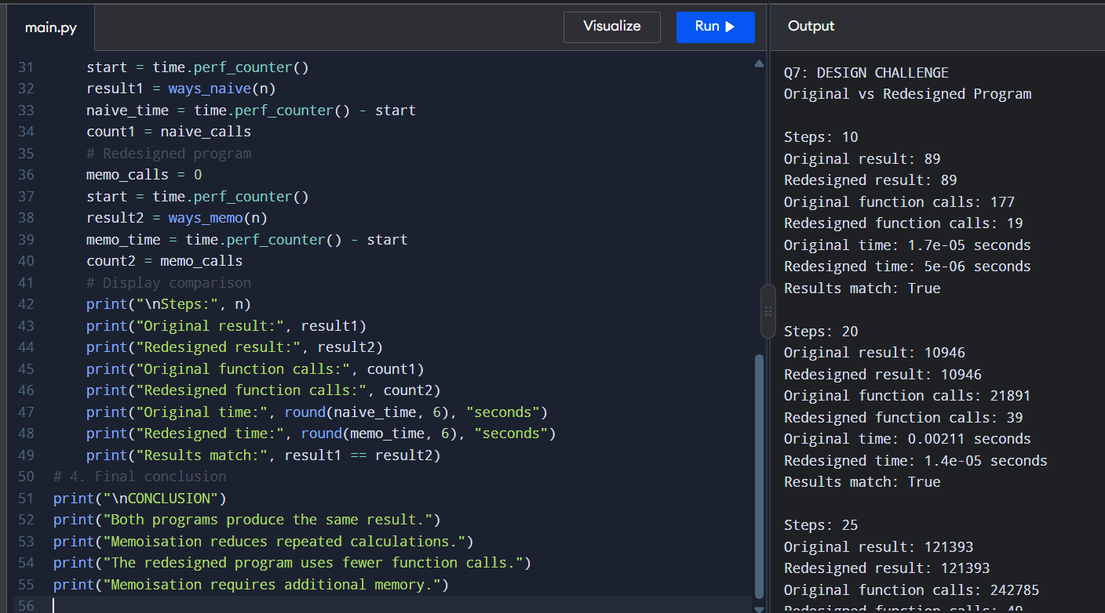
OUTPUT:

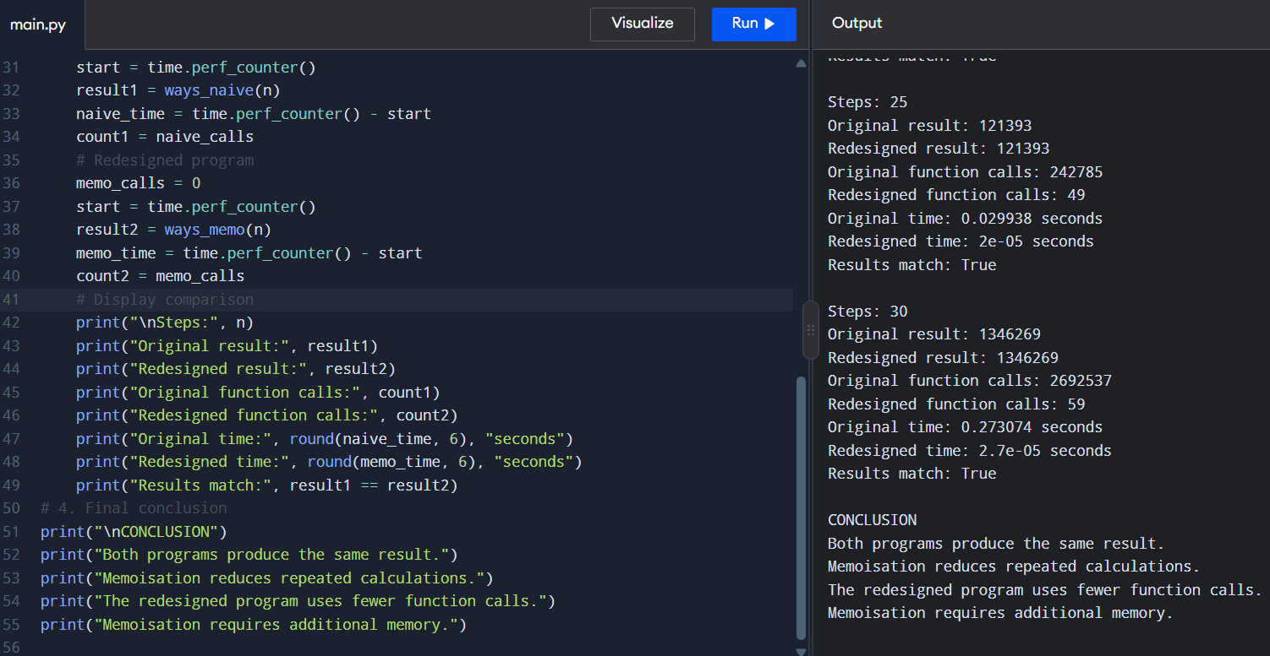

Expected console output (redesigned memoised solution)
Original vs Redesigned Program
Steps: 10 | Original result: 89 | Redesigned result: 89 | Original function calls: 177 | Redesigned function calls: 19 | Results match: True
Steps: 20 | Original result: 10946 | Redesigned result: 10946 | Original function calls: 21891 | Redesigned function calls: 39 | Results match: True
Steps: 25 | Original result: 121393 | Redesigned result: 121393 | Original function calls: 242785 | Redesigned function calls: 49 | Results match: True
Steps: 30 | Original result: 1346269 | Redesigned result: 1346269 | Original function calls: 2692537 | Redesigned function calls: 59 | Results match: True
Execution times are intentionally not filled with invented values. Run the program to record the actual times printed on your computer.

